EXP 7 Monitoring HTTP and HTTPS packets using Wireshark
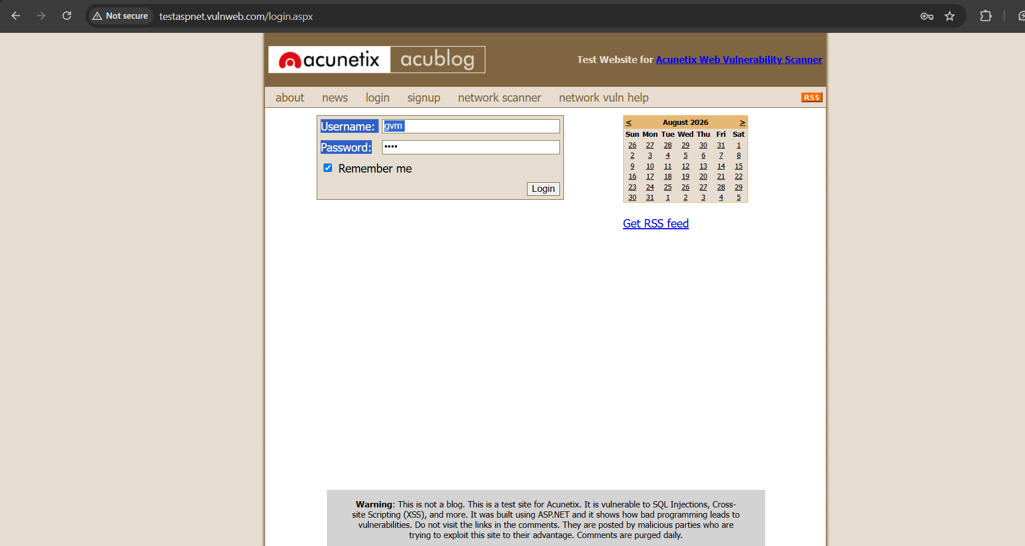
OBJECTIVE 1 HTTP

OUTPUT :
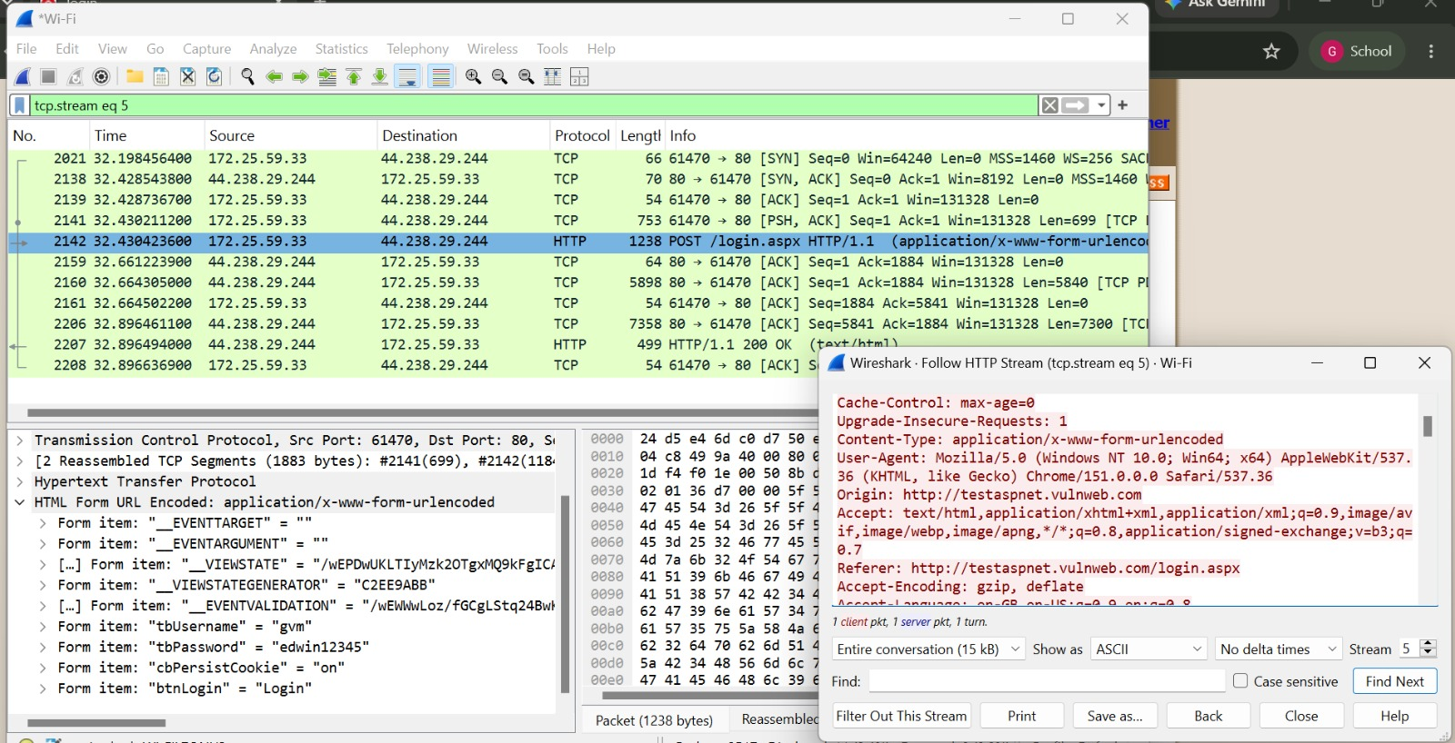

OBJECTIVE 2 : HTTPS


OUTPUT:
